**Bahria University Karachi Campus**

# Department of Software Engineering

# ASSIGNMENT # 03 – Fall 2020

|  |  |  |
| --- | --- | --- |
| Course Title: **Computing Fundamentals** |  | Course Code: **CSC-110** |
| Class: **BSE – 1(A/B)** |  | Shift: **Morning** |
| Course Instructor: **Dr. Salahuddin** |  | Max. Marks: **6.5** |
| Date: **3rd Jan 2021** |  | Due Date: **9th Jan 2021** |

|  |  |  |  |  |  |  |  |  |  |  |  |  |  |
| --- | --- | --- | --- | --- | --- | --- | --- | --- | --- | --- | --- | --- | --- |
| Student’ Name: M MUAZ SHAHZAD  Registration #: 02-131202-081 | |  |  |  | | --- | --- | --- | | **Q#** | **Marks Assigned** | **Marks Obtained** | | **1** | **3.5** |  | | **2** | **3** |  | | **Total** | |  | |

**Note:** (i) Please submit your assignment via BU-LMS in MS-Word document only.

(ii) Submit assignment before due date. After due date, LMS system will not accept your submission.

**[CLO 1]**  
  
**Q1.** Define and explain the following network terminologies:  
  
  
  
  
  
  
  
  
  
  
  
  
  
  
  
  
  
  
  
  
  
  
1) **Hub

**[Marks 3.5]**

**

**4) NIC / LAN card  
  
  
  
  
5)Bridge  
**

**6) Repeater  
**

**7) Connectors  
**

**[Marks 3]**

**Q2**. Explain the following with applications and real-time examples:

1. Security and privacy issues on Internet  
     
   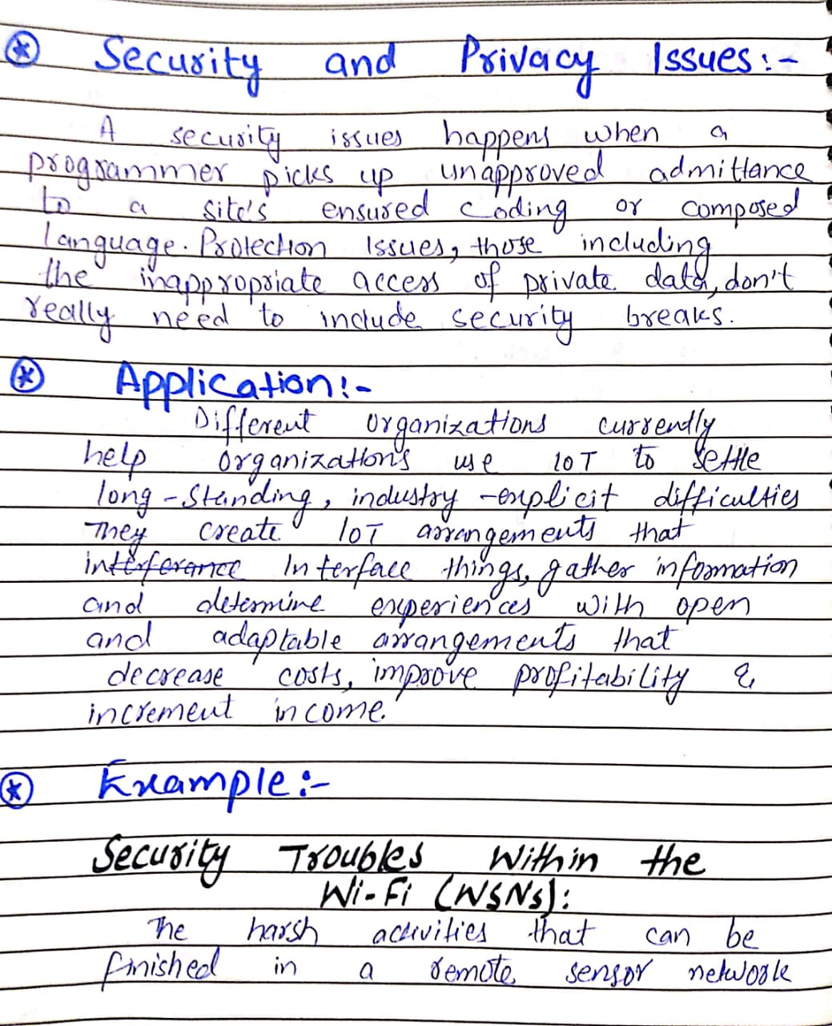  
   Text, letter

   Description automatically generated
2. Wired and Wireless Communication Media

**3) Virus and Threads**

_________________________________-End-_______________________________